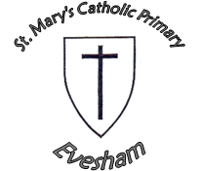
English Objectives
We are learning to:
- Write letters for different purposes, e.g. to complain or inform
- Use the features of a newspaper accurately
- Improve our descriptive writing skills
- Use a range of conjunctions accurately to extend our ideas
- Consolidate our use of basic punctuation
- Use punctuation for effect
- Spell, understand the meaning of and use all of the Year 5/6 spellings
- Open sentences in a variety of ways
- Proofread our writing carefully
- Explore Myths and legends
- Speak confidently in discussions and presentations

